SMART WATCH

IN ENGLISH

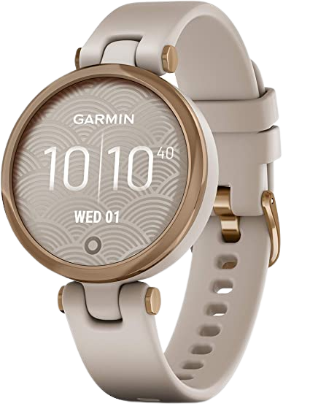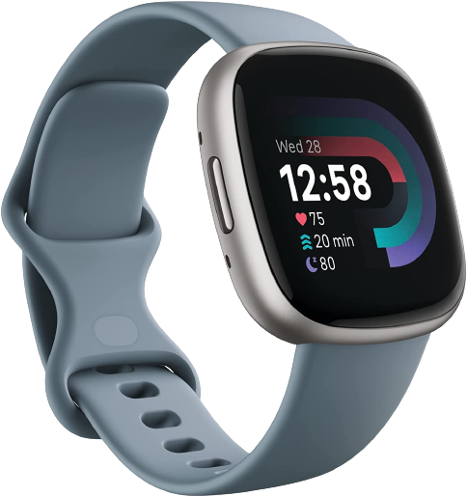

PHAL HIM – CLASS B

- MY BUYER GUIDE ON THE WATCH –

# TABLE OF CONTENT

## - Presentation of the products

## Garmin lily

1.2 Fitbit versa

## Which watch should you buy?

## Let s talk to watch serices



- PAGE 1 -

- MY BUYER GUIDE ON THE WATCH –

### - Presentation of the products

 1.1 Garmin lily[1]

Lily™ is the small and stylish smartwatch you’ve been waiting for. With a flick of your wrist or a tap of your finger, the stylish patterned lens lights up to reveal a bright touchscreen display that disappears when you’re done with it. Always be connected to what matters with call, text and email notifications right on your wrist.

##### 1.2 Fitbit versa[2]



Get better results from your workout routine with Versa 4 + Premium. Know when you’re up for a challenge or need a recovery day with your personalized Daily RGet better results from your workout routine with Versa 4 + Premium.

- MY BUYER GUIDE ON THE WATCH –

### Which watch should you buy?

Lily ™ is the small and stylish smartwatch you have been waiting for. With a flick of your wrist or the touch of a finger, the stylishly patterned lens illuminates to display a clear touch screen that disappears when you are done. Always keep up with what's important with phone, text and email notifications on your wrist Better than Versa 4 + Premium.

|  |  |  |
| --- | --- | --- |
|  | Garmin lily | Fitbit versa |
| Price | $198.88 | 159.95$ |
| Sold By | jerimac LLC | Amazon.con |
| Color | Rose Gold and Light Tan | Waterfall Blue/Platinum |
| Item Dimensions | 5.51 x 0.2 x 1.36 inches | 1.57 x 0.43 x 1.57 inches |
| Item Weight | 0.85 ounces | 7.04 ounces |
|  |  |  |
|  |  |  |

- PAGE 3 -

1. Small GPS Smartwatch with Touchscreen and Patterned Lens, Rose Rose Gold and Light Tan
2. 4 Fitness Smartwatch with Daily Readiness, GPS, 24/7 Heart Rate, 40+ Exercise Modes, Sleep Tracking and more, Waterfall Blue/Platinum, One Size (S & L Bands Included)

   - PAGE 2 -